Used Car Listings
KPI & Market Insights Report
Dataset: cleaned_imputed.csv → car_data_features.csv | 37,708 listings across 46 brands, 382 models, 617 cities

Headline KPIs
37,708  Total Listings | 46  Unique Brands | 382  Unique Models

₹5,25,000  Median Listed Price | 10 years  Median Car Age | 56,782 km  Median Odometer

70.3%  First-Owner Share | 70.1%  Metro-City Share | 23.5%  Automatic Share

Fuel, Segment & Ownership Mix
Metric | Value
Petrol share | 57.6%
Diesel share | 38.7%
CNG / other fuel share | 3.7%
Luxury-brand share | 7.3%
Average discount applied | 0.4% of pre-discount price

Visual KPI Dashboard

1. Price Distribution
The bulk of listings cluster well under ₹10L, with a long tail of premium and luxury vehicles pulling the mean (₹7.83L) above the median (₹5.25L).
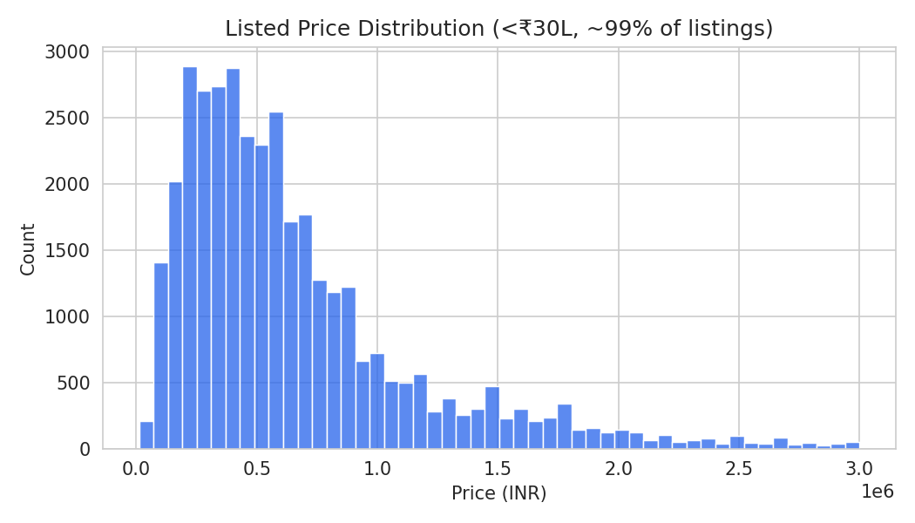

2. Median Price by Brand
Among the top 15 brands by listing volume, luxury and premium marques command the highest resale medians, while mass-market Indian and Japanese brands anchor the volume end of the market.
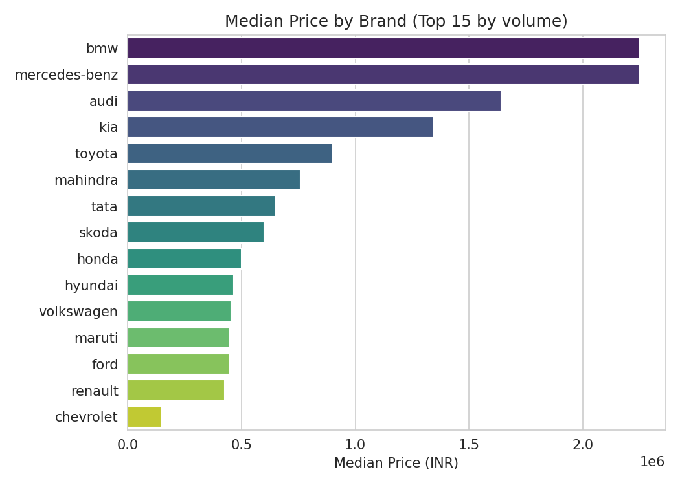

3. Depreciation Curve
Median price falls sharply over the first 5-7 years of ownership and then flattens, typical of used-vehicle depreciation curves.
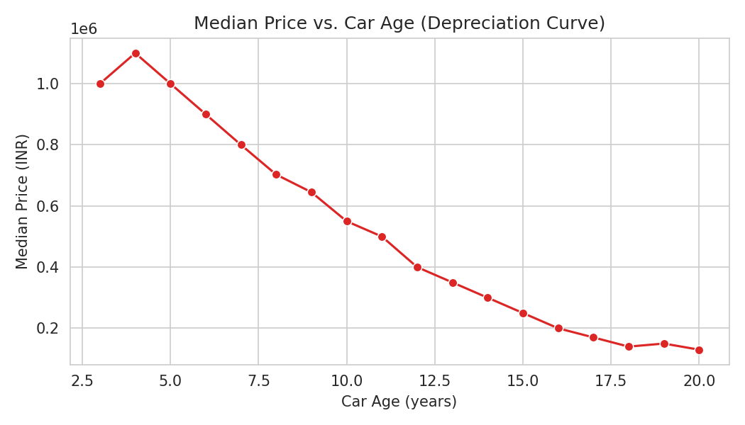

4. Fuel Type & Transmission Mix
Petrol and manual transmission dominate the listings, reflecting the overall composition of the Indian used-car market.
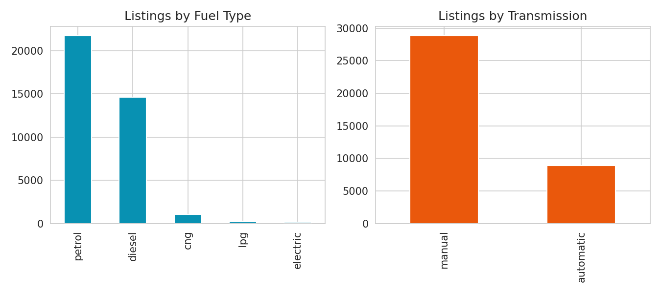

5. Metro vs. Non-Metro Pricing
Metro-city listings command a meaningfully higher median price than non-metro listings, consistent with higher demand and buyer purchasing power in large cities.
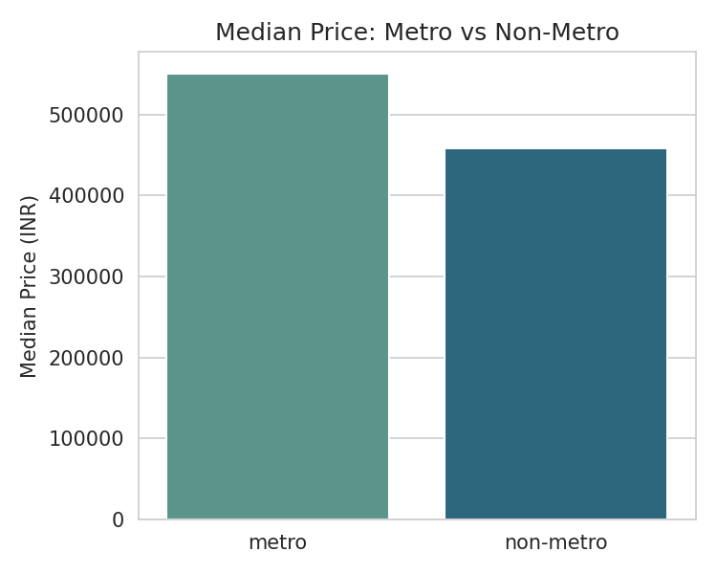

6. Top Models by Listing Volume
Compact hatchbacks and sedans from mass-market brands make up the highest-volume listings, reflecting their popularity and larger used-car supply base.
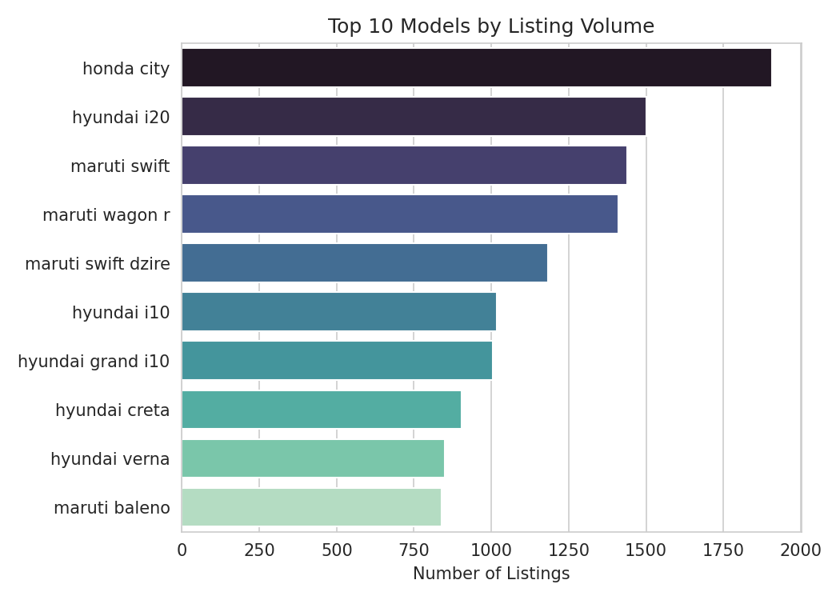

Methodology Notes
- Source data was de-duplicated (105 rows removed) and had 3 clear data-entry errors (impossible odometer readings, one price typo) corrected via imputation before KPIs were computed.
- Missing values across 33 columns were imputed hierarchically using similar-car groupings (same oem+model+variant → oem+model+fuel+transmission → oem+model → oem+body → global).
- Engineered features used in this report: car_age, km_per_year, discount_pct, is_luxury_brand, city_tier, brand/model popularity, and feature-richness counts.
- "Metro" cities: Mumbai, New Delhi, Bangalore, Chennai, Kolkata, Hyderabad, Pune, Ahmedabad, Gurgaon, Noida. All others classified as non-metro.

